**Section06 Razor authentication**

**Notes:-**

**1-by default in order to apply authentication and authorization on backend you have to use [Authorize] on the target action you want**

**And on the view you have to check the authorization policy as below**

**@using Microsoft.AspNetCore.Authorization**

**@inject IAuthorizationService authorizationService**

**@if ((await authorizationService.AuthorizeAsync(User, "Claim.DoB")).Succeeded){**

**<h1>User has DOB Claim</h1>}**

**2-so in order to apply authorization on razor pages you should do the following steps**

**A-create folder > Pages > Razor > Add new Razor Page Empty with 3 views**

**Indx.cshtml , Secure.cshtml , Policy.cshtml**

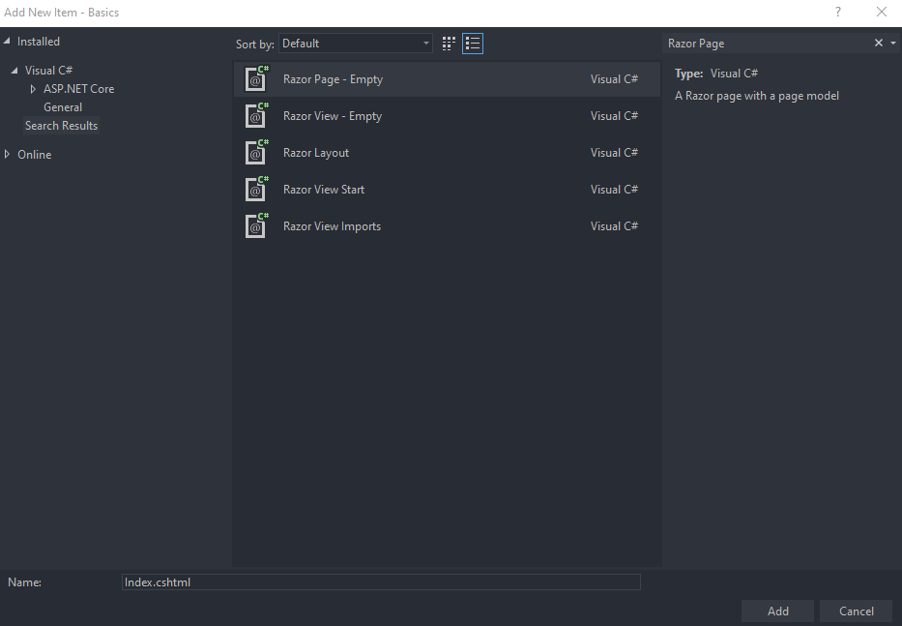

**B-create folder > Pages > RazorSecured > with 2 views**

**Anon.cshtml , Secured.cshtml**

**3-on the startup.cs we set the configuration for the razor pages as below**

**In configureService**

**//in order to give authorization policy for target page**

**confg.Conventions.AuthorizePage("/Razor/Policy","Admin");**

**//in order to give any authorization for the target page**

**confg.Conventions.AuthorizePage("/Razor/Secure");**

**//in order to give authorization on the folder layer so any page beyond**

**//that will inherit that authorization**

**confg.Conventions.AuthorizeFolder("/RazorSecured");**

**//in order to give anonmous for the target page**

**confg.Conventions.AllowAnonymousToPage("/RazorSecured/Anon");});**

**In Configure action**

**app.UseEndpoints(endpoints =>{**

**endpoints.MapDefaultControllerRoute();**

**endpoints.MapRazorPages();});**